**Teacher: V. Wellington; K. Blair**

**Weeks 1 -2**

**Date:** September 14 – 25, 2020

**Grade/Class:** 11A/11G

**Subject:** Literature – Prose Fiction (The Short Story)

**Lesson Topic:** Introduction to Prose Fiction; The Unseen Paper (The Prose Extract)

**Subtopic:**  The Unseen Paper (The Prose Extract);

“The Day the World Almost Came to an End”

**General Objectives:** This lesson aims to:

* develop students’ knowledge and understanding of the nature of the prose fiction and their competence in analyzing a prose passage

**Specific Objectives:** Students should be able to:

1. Watch a video to get a better understanding of prose
2. Take notes from these videos
3. write answers to questions set on a prose extract (past paper)
4. read the story “The Day the World Almost Came to an End”
5. correctly identify elements of the short story using a table
6. Orally discuss nature and effectiveness of the elements of this short story

**Materials:** YouTube videos; English B CSEC Past Paper (Paper 1), May 2016; A World of Prose for CSEC (New Edition),

**ACTIVITY:**

**INSTRUCTIONS: Complete the following activities and send your responses by email to your teacher. You may type your responses in a Word document or type them in the body of your email. You may also write the assignment in your notebook and send a picture of the response by email.**

**For Week 1 (September 14 – 18)**

1. Follow the links below and watch the YouTube videos to learn something about prose and prose fiction. Take notes of what you learnt. (You do not need these notes to your teacher):

* “Major forms of Prose” by Mometrix Academy <https://www.youtube.com/watch?v=BIjcsCIBVkU&t=45s&ab_channel=MometrixAcademy>
* “Basic Elements of Prose Fiction” by Auya Solomon <https://www.youtube.com/watch?v=OhVy3TOe59w&t=8s&ab_channel=AyuaSolomon>

1. Read the documents at the end of this activity sheet for more information on prose fiction, and the short story in particular.
2. Read the prose extract from the CSEC past paper at the end of the document. Answer the questions these questions set on it:
3. Identify the setting of the extract (1 mark)
4. Suggest two reasons why the narrator wanted to sing the solo at the annual entertainment. (2 marks)
5. Describe the central conflict in the extract. (3 marks)
6. State TWO characteristics of the narrator. Support EACH response with evidence from the extract. (4 marks)
7. Identify the literary device used in “petite, pretty and as pious as angeks in our prayer books” (lines 10 – 11) and comment on its effectiveness. (3 marks)
8. Discuss the writer’s use of contrast in the extract. ( 4marks)’
9. Suggest ONE reason why the writer included Mr. Charlie’s response to the narrator’s performance. Support your response with evidence from the extract. (3 marks)

**Week 2 (September 21 – 25)**

1. Read the story “The Day the World Almost Came to an End” in A World of Prose and complete the following:
2. Use the table below to help you correctly identify the elements of the short story

|  |  |  |  |  |  |  |
| --- | --- | --- | --- | --- | --- | --- |
| Plot (summary) | Conflict | Resolution of conflict | Main characters | Point of View | Point of view | Themes |
|  |  |  |  |  |  |  |

1. Answer the following questions on the short story “The Day Almost Came to an End”
2. Why was the girl narrator so scared that the world was coming to an end?
3. Why was the church referred to as the “axis” of the village (what does this expression mean)?
4. What was her cousin’s name and what had she done to upset the narrator at the beginning of the story?
5. How old is the narrator?
6. What were the sins she was concerned she would burn for?
7. What is the narrator’s relationship with her father? How can you tell?
8. What is ironic about the narrator’s response to the world coming to an end?
9. What was it that caused the narrator to go running around the plantation at night? What was really happening?
10. How does the narrator show growth at the end of the story?

PAPER 1 Activity

SEE PASSAGE ON NEXT PAGE

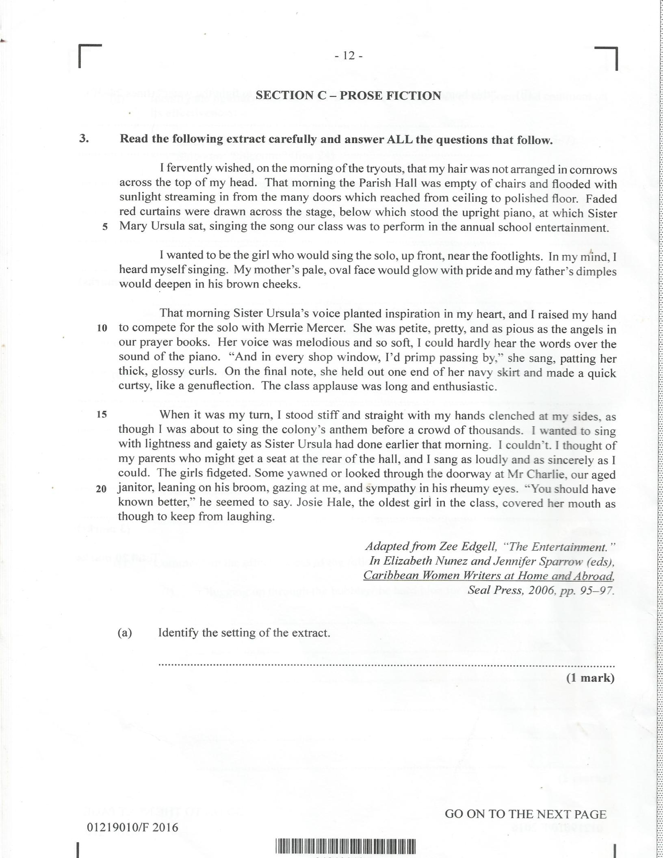

**NOTES**

**Prose Fiction: The Short Story and the Novel**

**What is a short story?**

“A short story is a brief work of prose fiction, and most of the terms for analyzing the component elements [i.e. plot, character, setting, point of view, theme, style], the types, and the narrative techniques of the *novel* are applicable to the short story as well… And as in the novel, the plot may be comic, tragic, romantic, or satiric; the story is presented to us from one of many available *points of view*; and it may be written in the mode of fantasy, realism or naturalism.” (Richard Gill, 2010, p.331)

**What is a novel?**

“The term “novel” is now applied to a great variety of writings that have in common only the attribute of being extended works of *fiction* written in prose. As an extended narrative, the novel is distinguished from the short story and from the work of middle length called the novelette; its magnitude permits a greater variety of characters, greater complication of plot (or plots), ampler development of milieu, and more sustained exploration of character and motives than do the shorter, more concentrated modes.” (Gill, 2010, p. 226)

**Difference between the short story and the novel:**

“The short story differs from the novel in the dimension that Aristotle called ‘magnitude’, and this limitation of length imposes differences both in the effects that the story can achieve and on the elaboration of the elements to achieve those effects…We can say that, by large, the short story writer introduces a limited number of persons, cannot afford the space for a leisurely analysis and sustained development of character, and cannot develop a dense and detailed milieu as does the novelist. The author often begins the story close to, or even on the verge of, the climax, minimizes both prior exposition and details of the setting, keeps the complications down, and clears up the denouement quickly – sometimes in a few sentences. The central incident is often selected to manifest as much as possible of the protagonist’s life and character, and details are devised to carry maximum import fro the development of the plot. This sparseness in the narrative often gives the artistry in a good short story higher visibility that the artistry in the more capacious and loosely structured novel.” (Gill, 2010, p. 331- 332) Hence the short story has more in common with a poem, than a novel.

**The differences outlined:**

* The short story has only one plot. The novel has two or more.
* The short story focuses on one or two major characters. The novel has many major and minor characters.
* The time frame in a short story is condensed to a day or just a few days. The time frame in the novel can cover any time span – up to several years.
* The short story normally has one main setting. The novel has many settings besides the main setting.
* Since the short story is limited in time, there is not much change in the characters or change occurs rapidly. In the novel the characters grow and changed more slowly and are more complex.
* The artistry in a short story is more apparent than in a novel.